Power BI Assignment 2 – DAX & Data Visualization
Observation and Analysis Steps

Step 1 : Created a New column “Location” by merging State and City, for example "Clothing Saree". Using
Location = CONCATENATE('List of Orders (1)'[State],CONCATENATE(", ",'List of Orders (1)'[City]))
Or
Using – Location = ('List of Orders (1)'[State] & “ , “ & 'List of Orders (1)'[City])
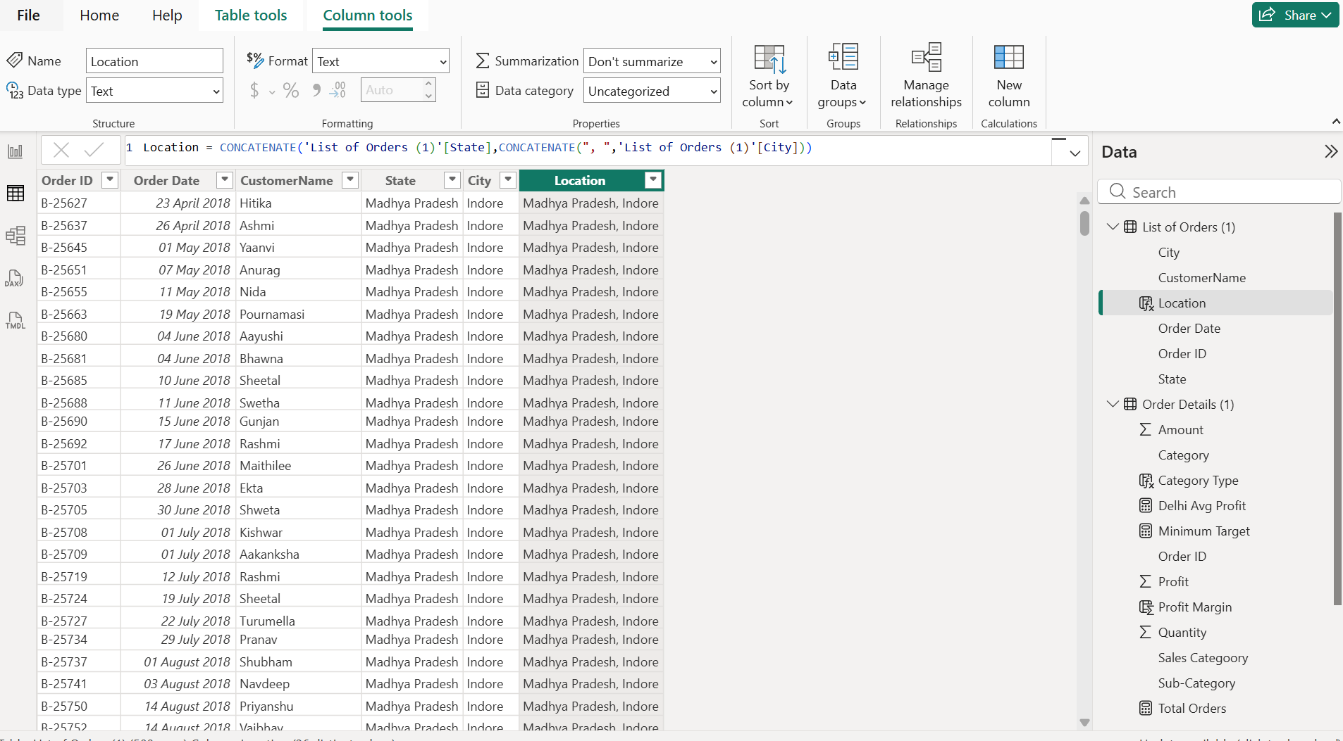

Step 2 : Merged Category and Sub Category to create a new Column called “Category Type”
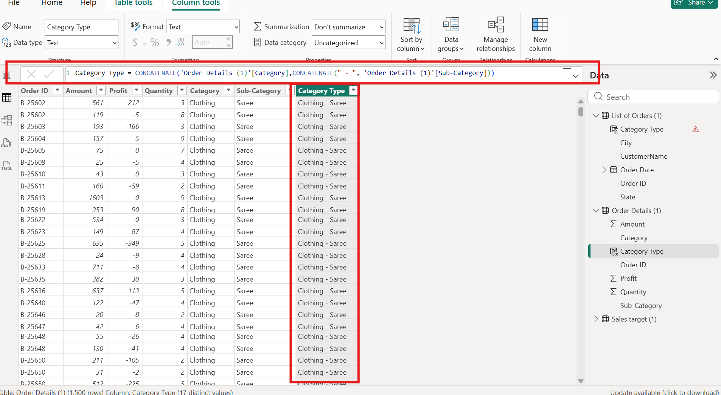

Step 3 : Calculated Sales Per Order using Total Sales = ‘Order Details (1) ‘[Amount] * ‘Order Details (1)’[Quality]
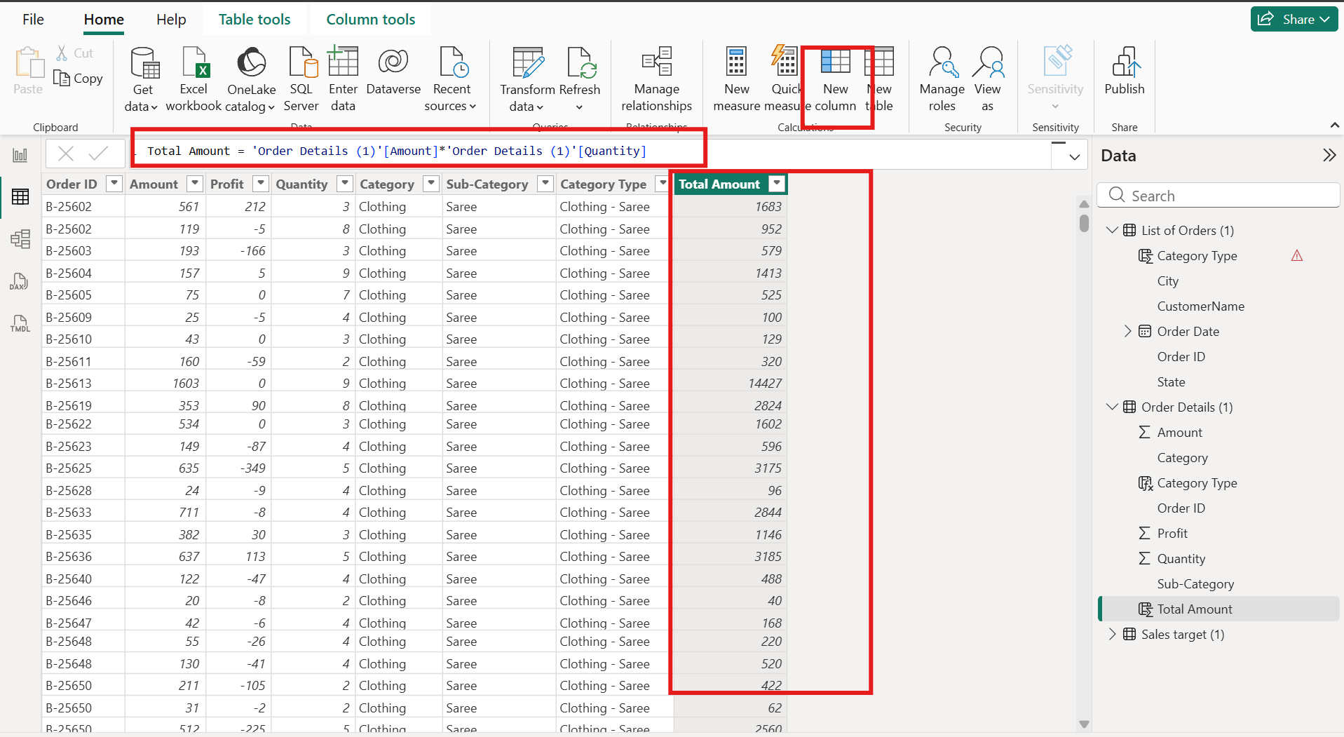

Step 4: Calculated the Average of Total Sales and created a new Column Using Switch function to return “Above Average” if the sales > Average sales amount and “Below Average” if the sales < Average sales amount

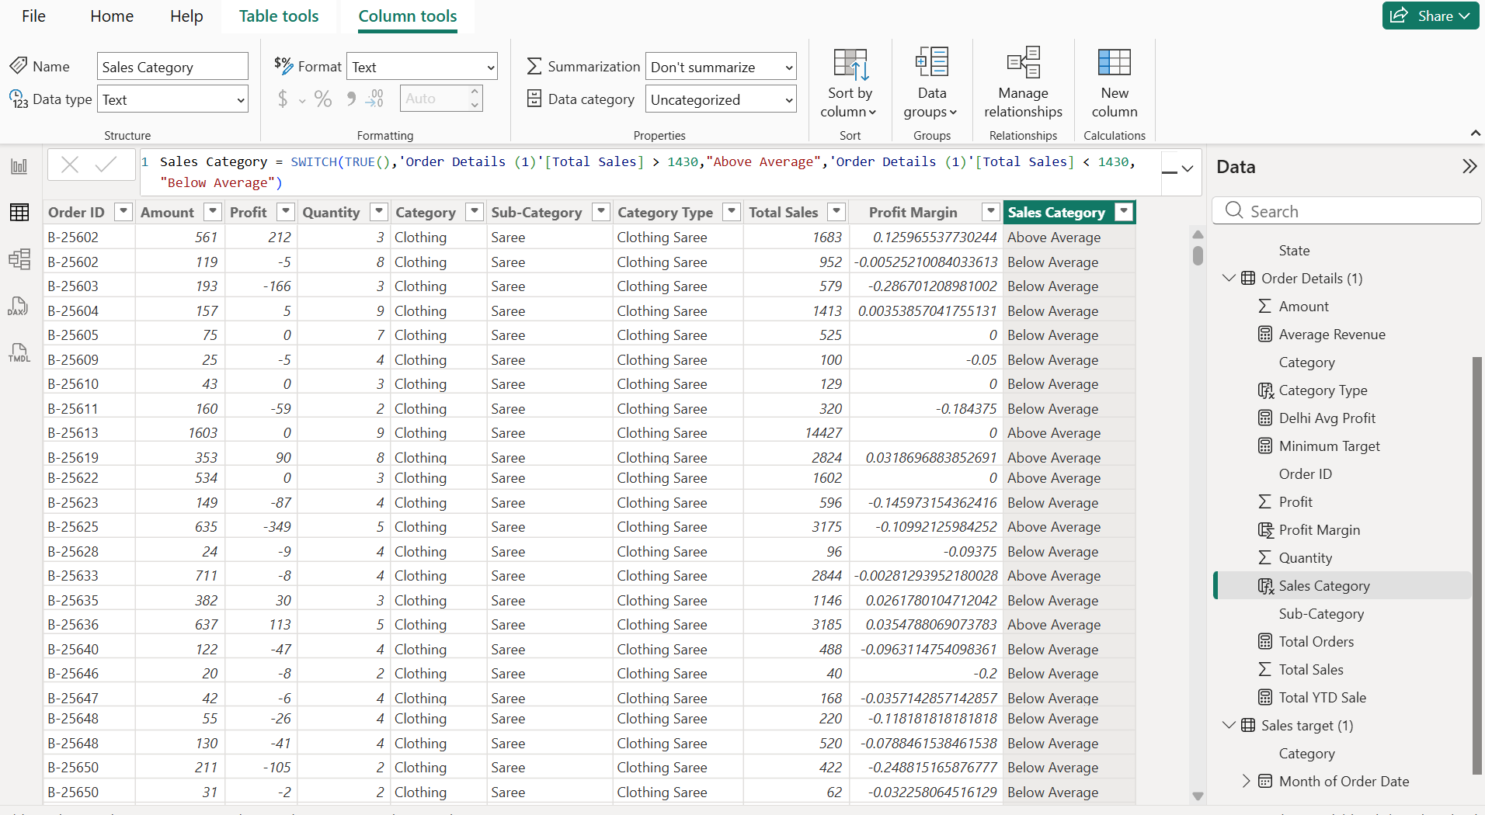

Step 5 : Using COUNTA created a Measure to find the total Orders
Total Orders = COUNTA()’order Details (1) ‘[Order ID]))
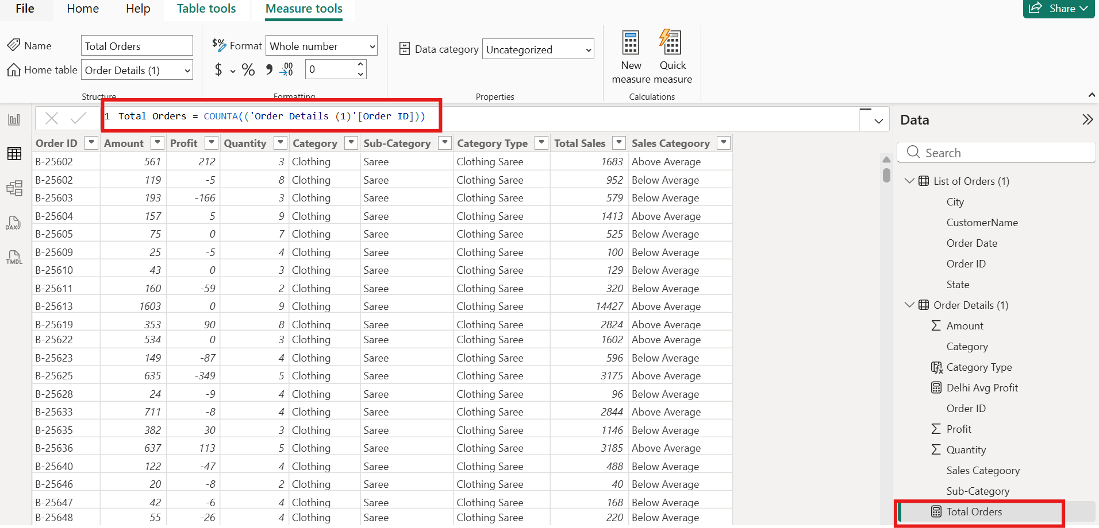

Step 6 : Created a Card in the report view to display the total No of Orders.
Created 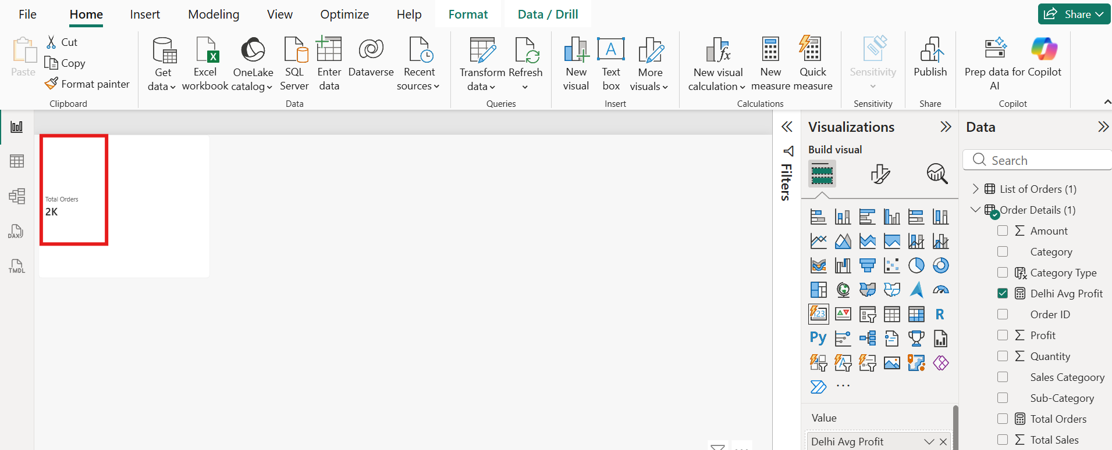

Step 7: Created New relationship between the tables
List of Order (Order ID) ---- Order Details (Order ID)
List of Order (Order Date) -----Sales Target (Month Of Order Date)
Order Details (Category) --- Sales Target (Category)

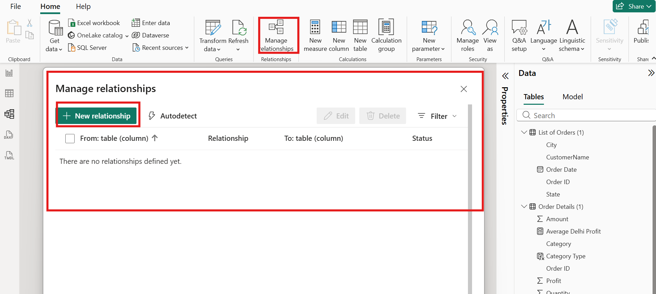

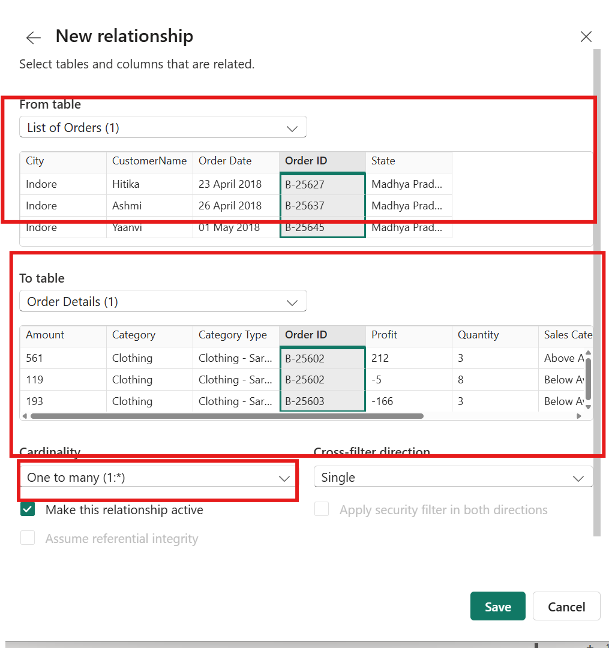

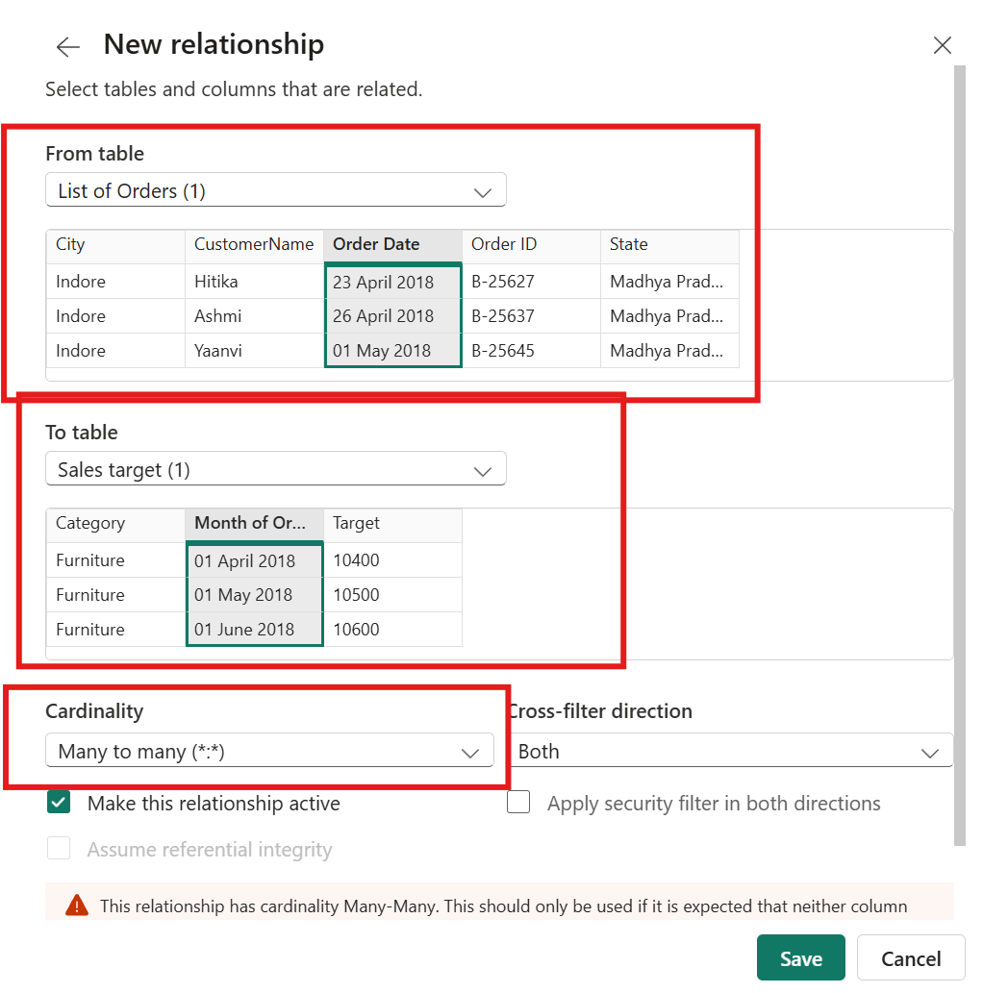

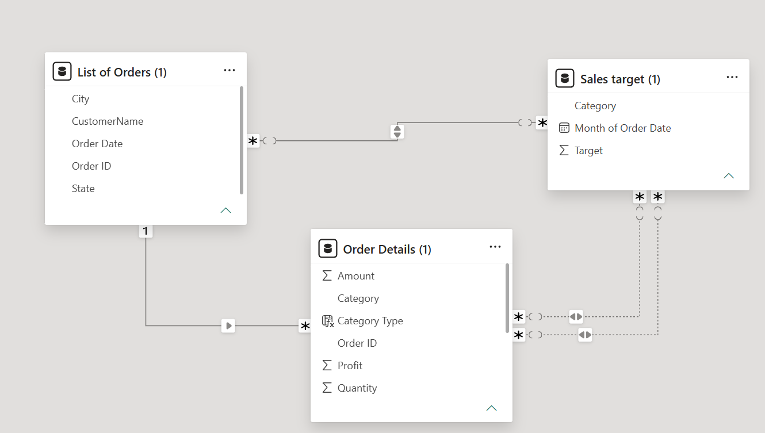

Step 8: Calculated Delhi Average Profit using Calculate (Average) function as shown in the image below and displayed the result in Card
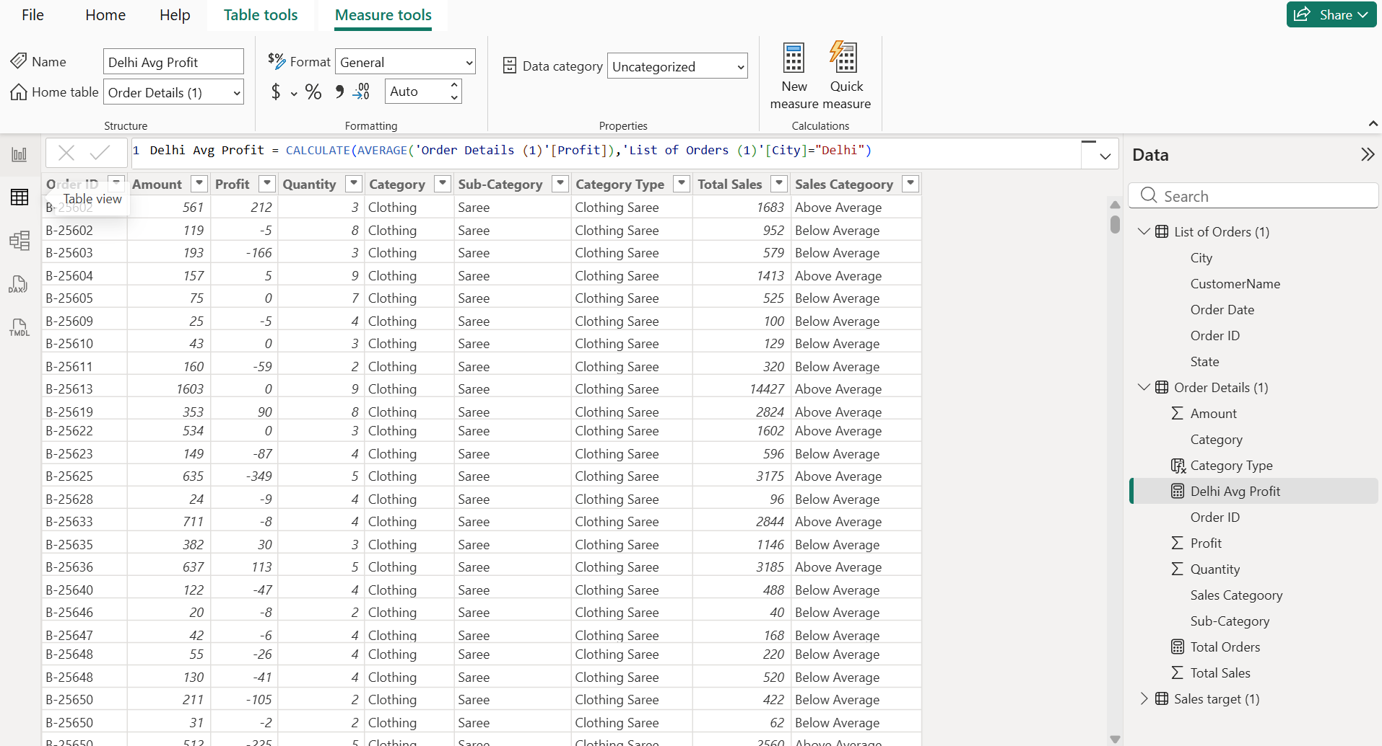
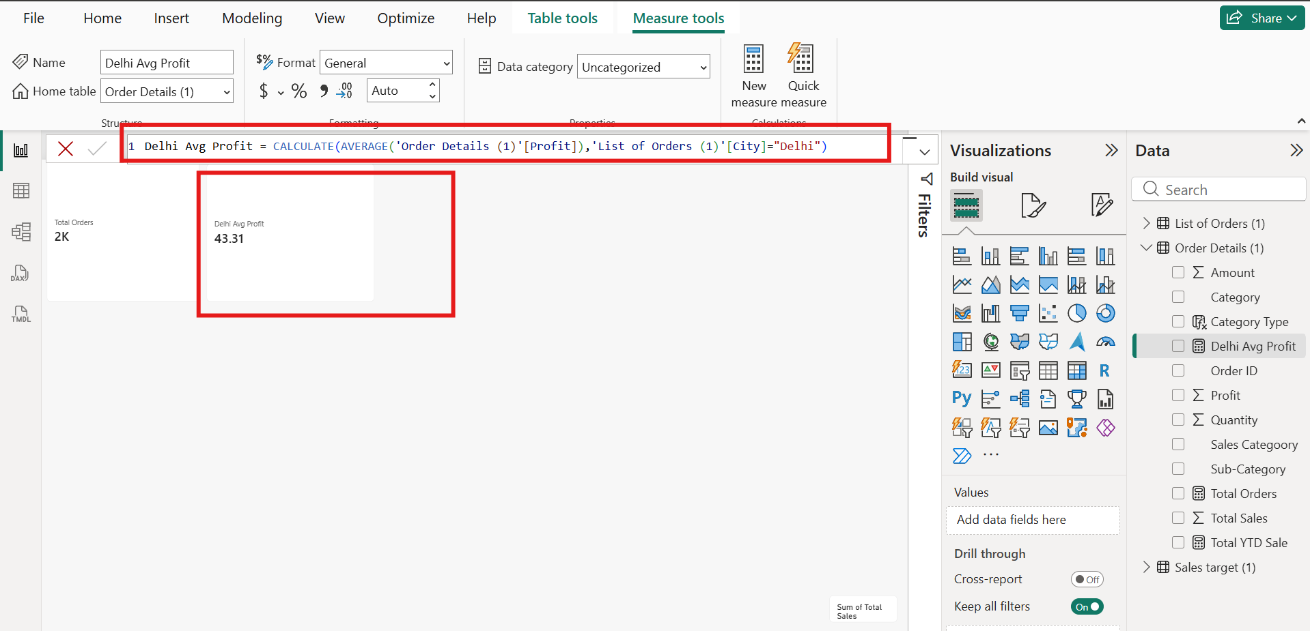

Step 9: Calculated the Total YTD sales using Dax function as shown in the below image
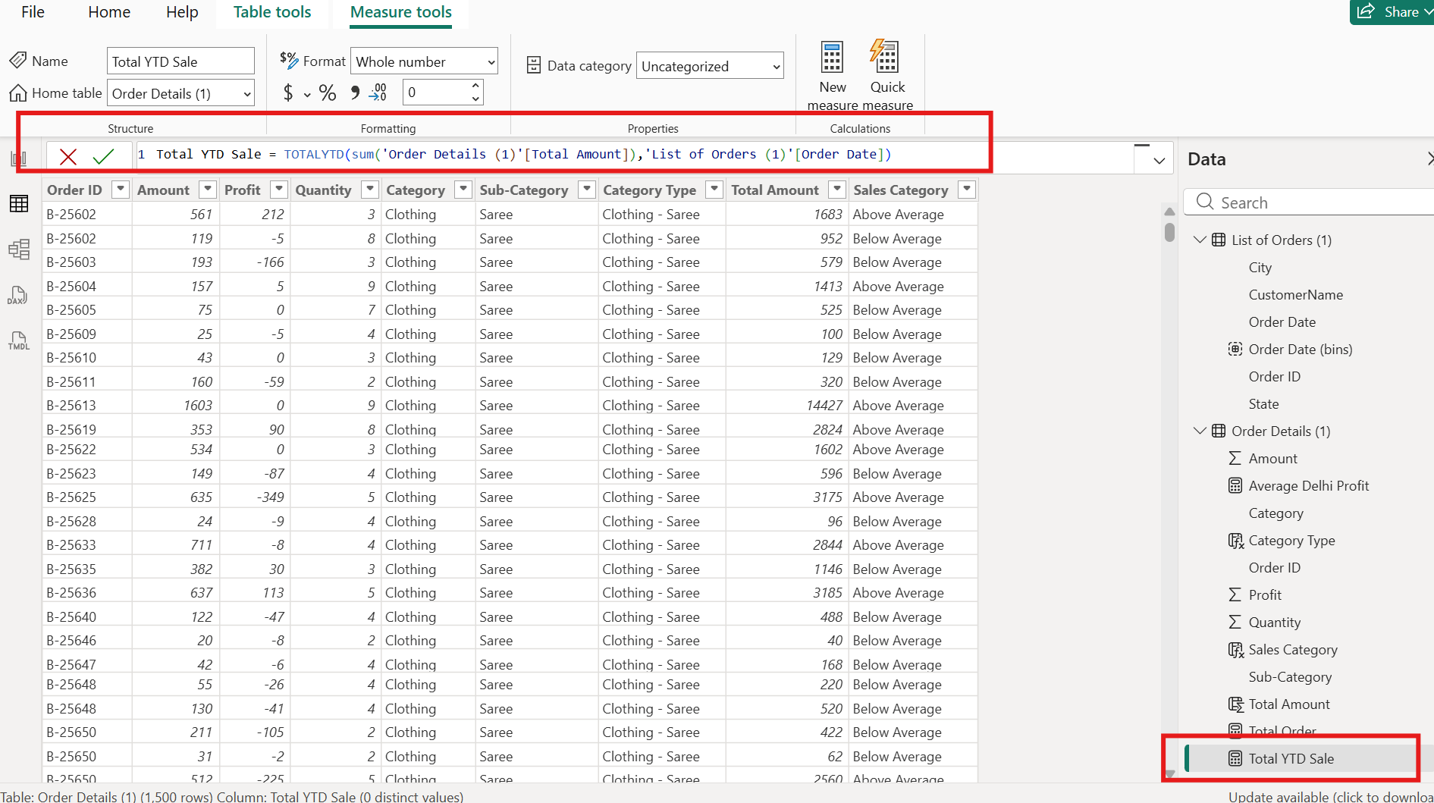

Step 10: Calculated YTD using below Dax Expression and displayed the same in the report view using Card
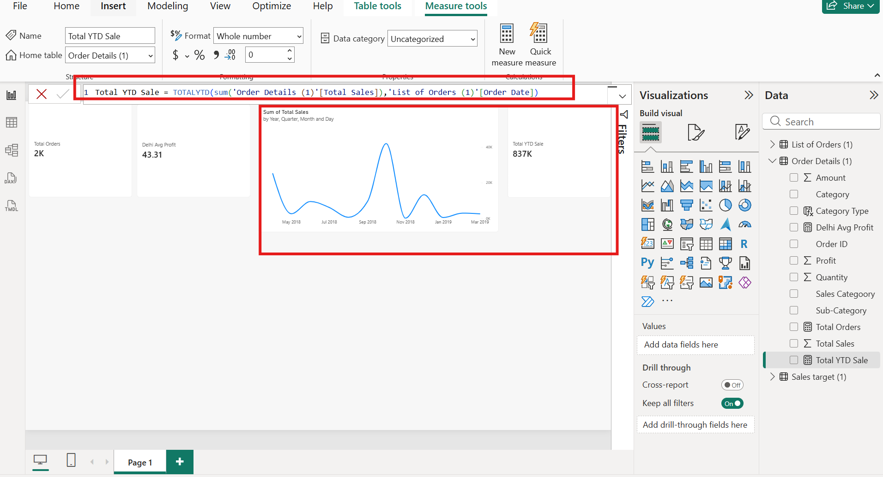

Step 11: Data Visualization:
Sales Target Achievement by Category: Compared actual Total sales with sales targets by category using a clustered column chart
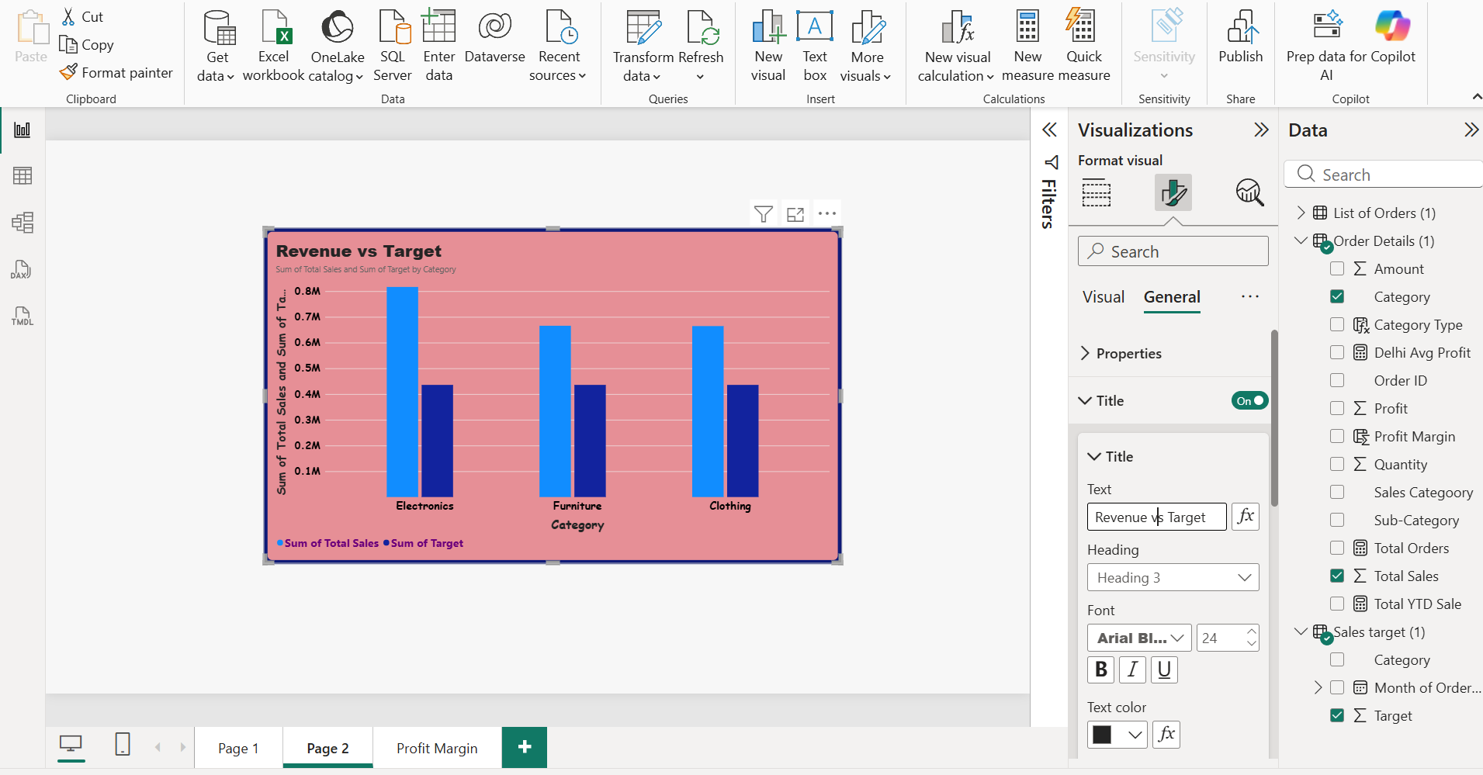

Step 12: Calculated Profit Margin using Divide Dax for analysing Max Profit Margin by Sub-Category:
Profit Margin = Divide(‘Order Details (1)’[Profit],’Order Details (1)’[Total Sales])

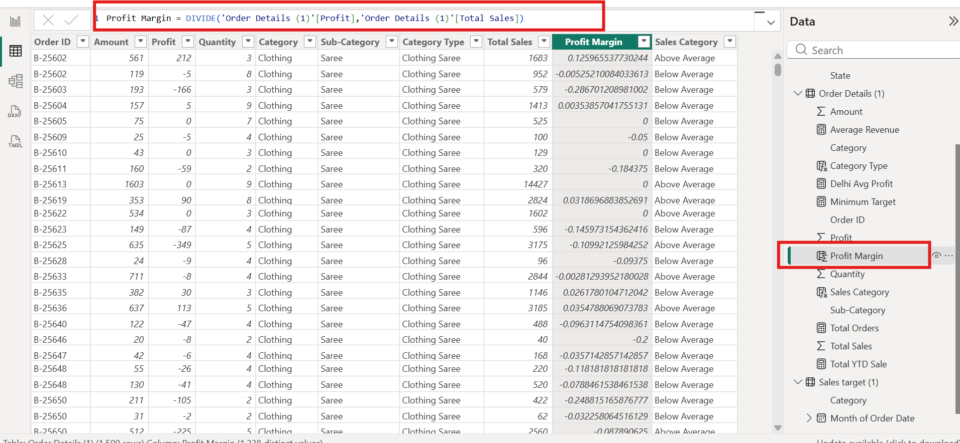

Step 14 : Max Profit Margin by Sub-Category:
Calculated a Profit Margin in % column and analysed the maximum profit margin for each sub-category of products using a donut chart.

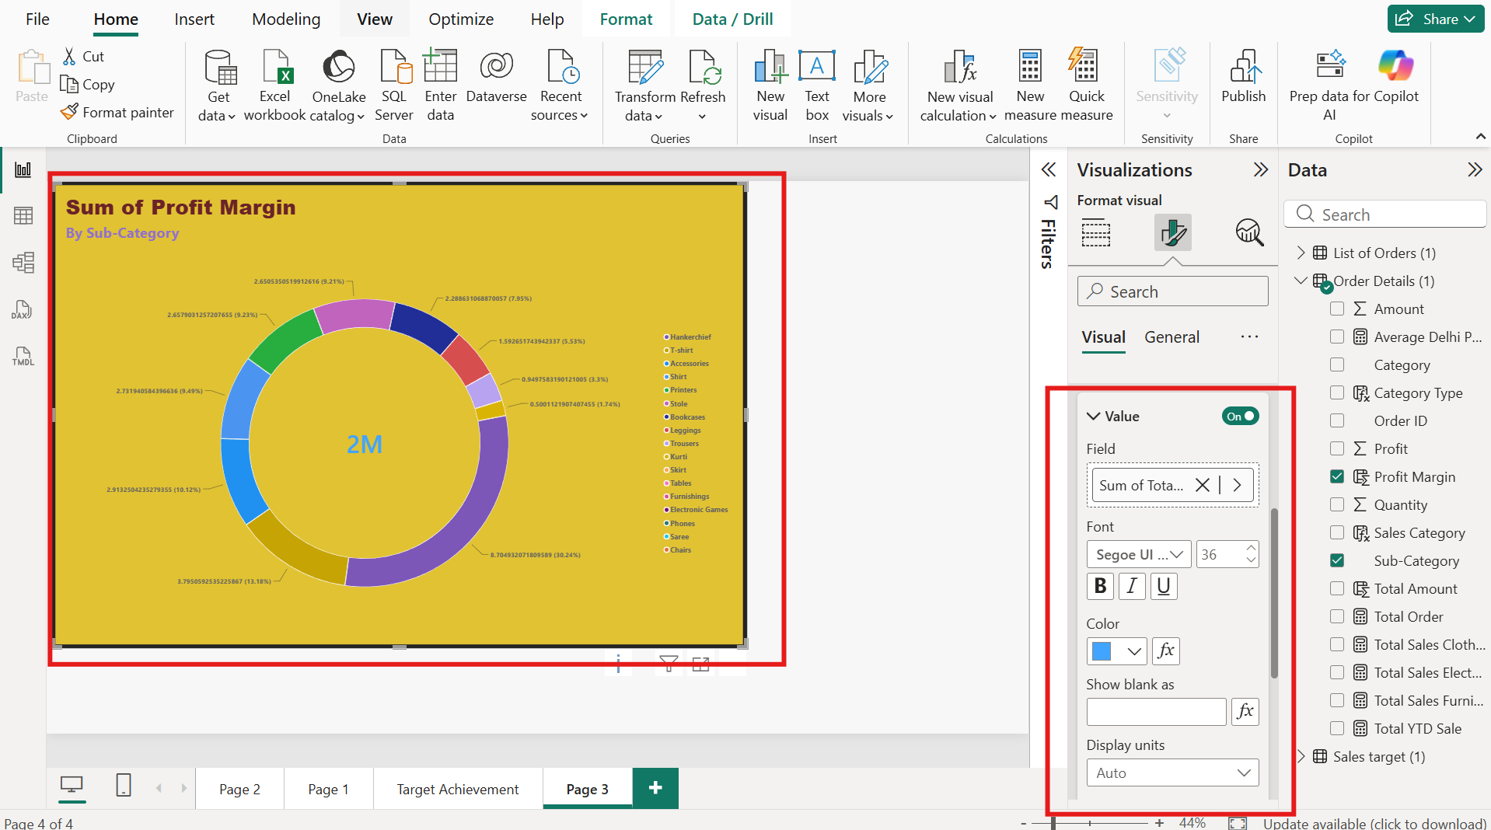

Customised the chart using Visualization filters as below:
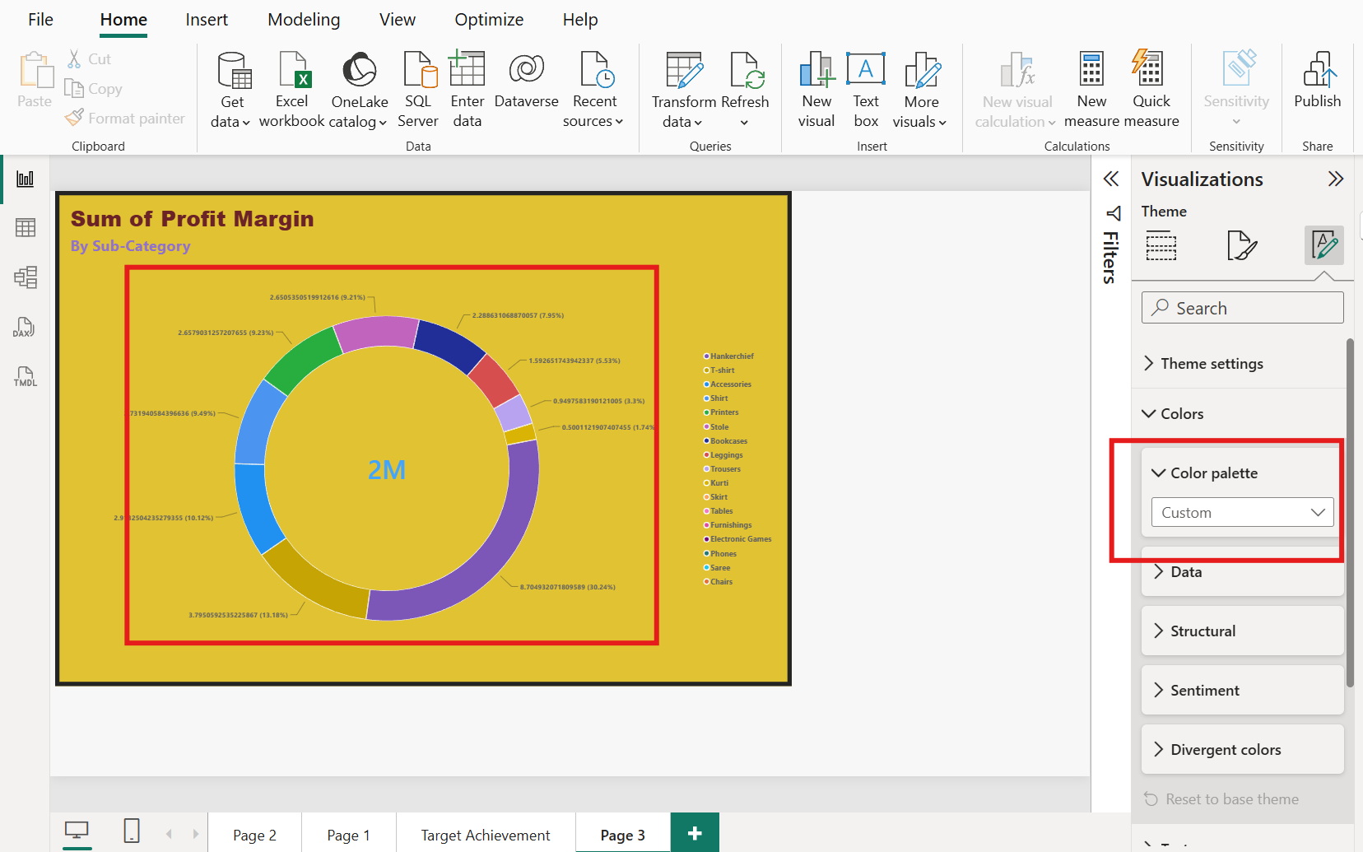
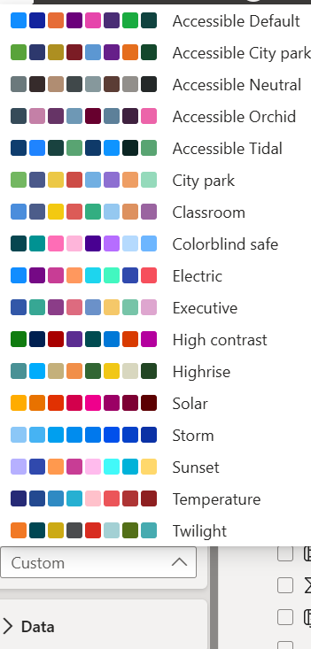
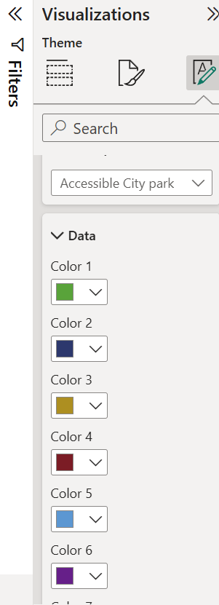
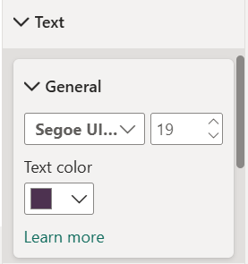
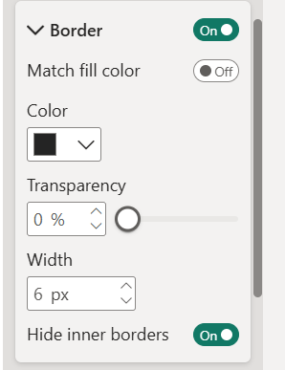

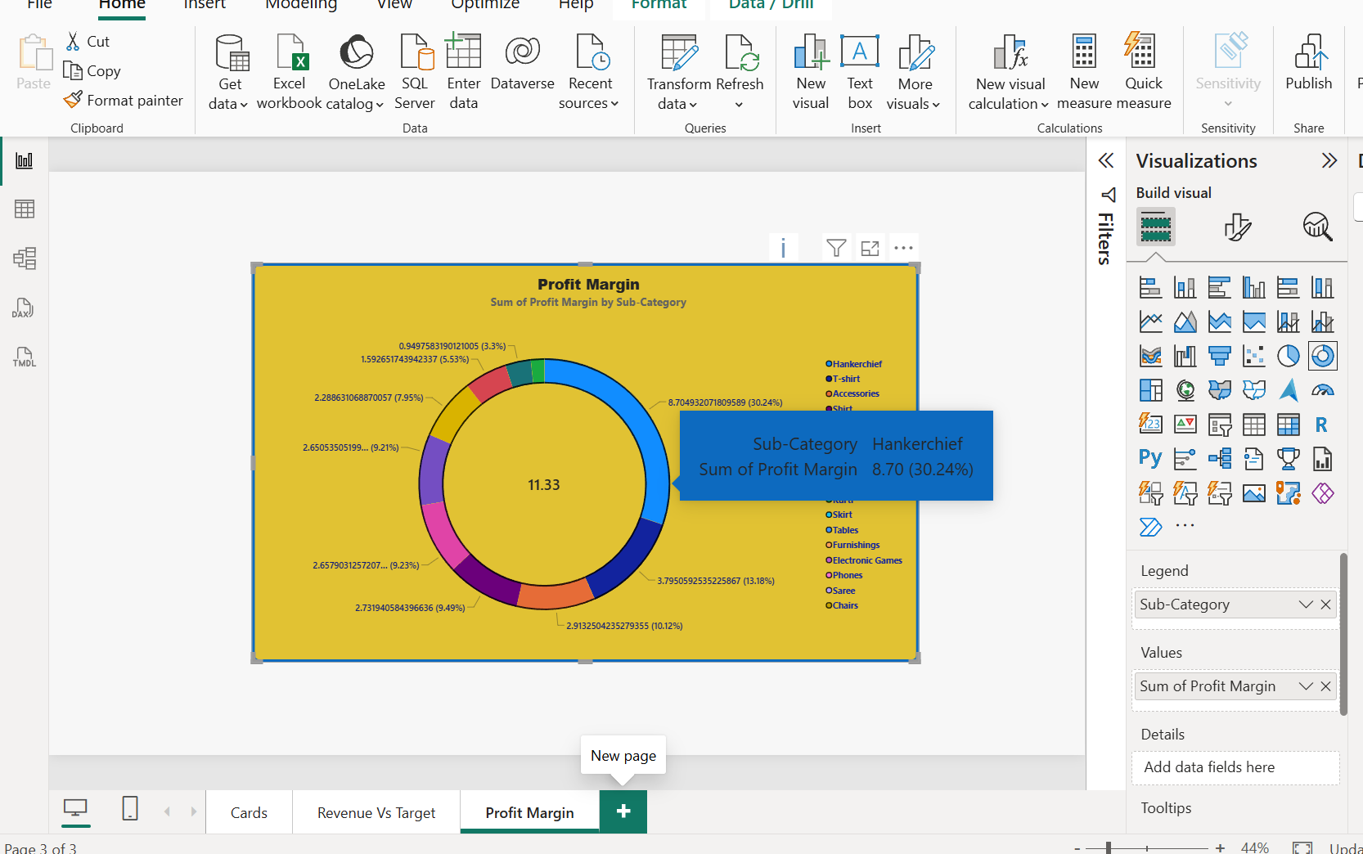

Step 15: Monthly Sales Trend: Shown the trend of monthly sales over time using a line chart using Order date in the X axis and Total sales in the X axis
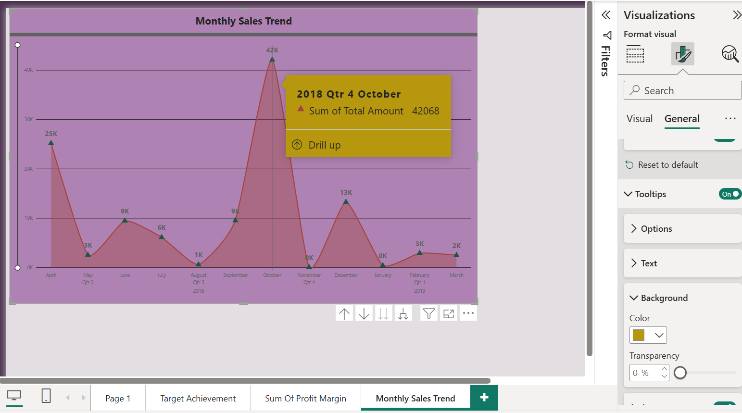

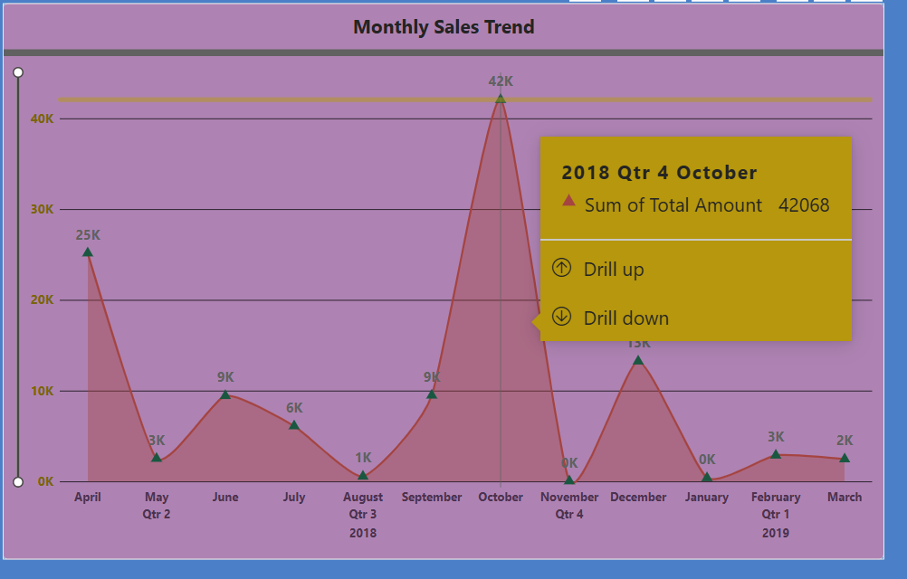

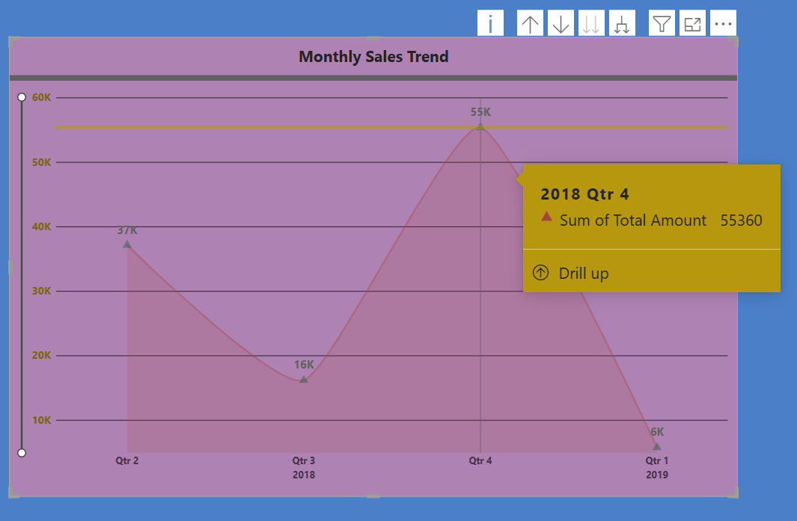

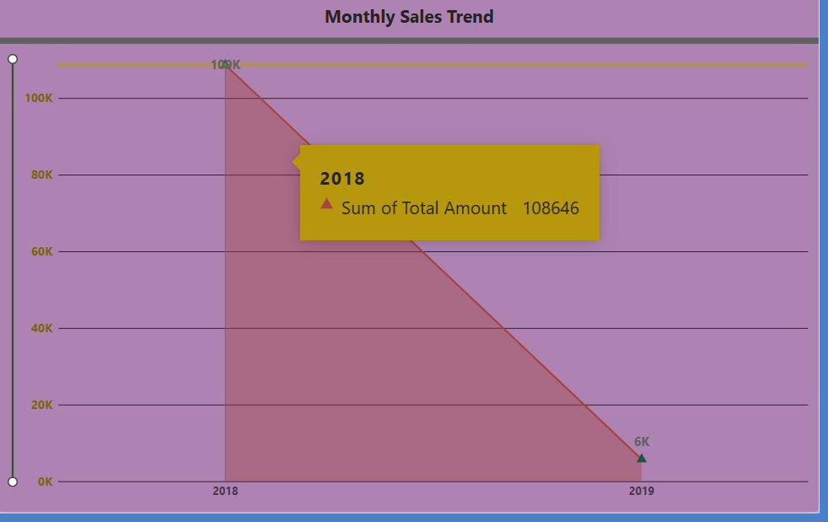

Step 16: Comparison of Profit and Quantity by Sub-Category:
Compared the relationship between profit and quantity sold for different sub-categories using a scatter chart as below
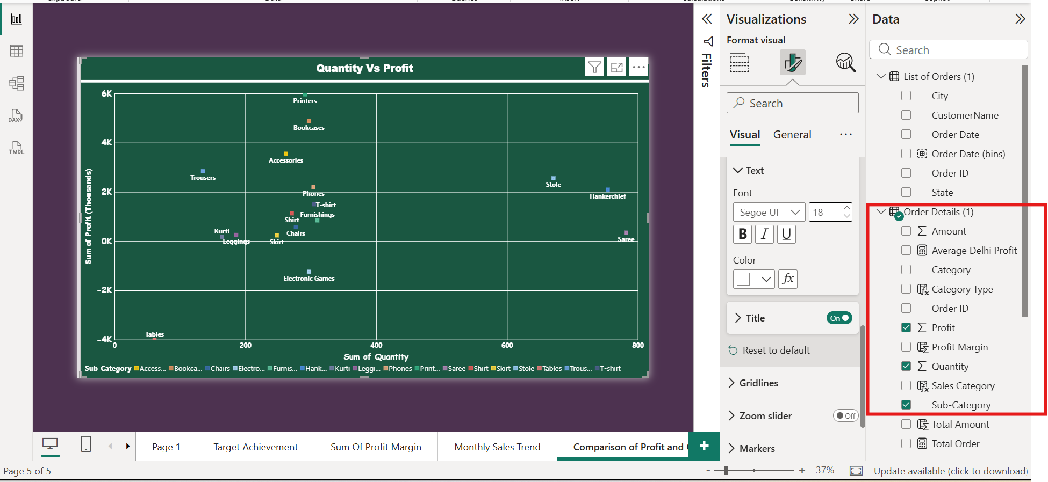
Step 17: Customised the chart using below options
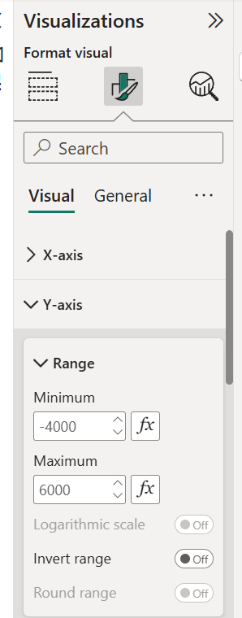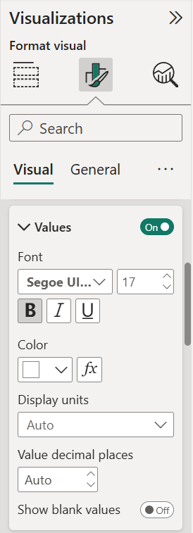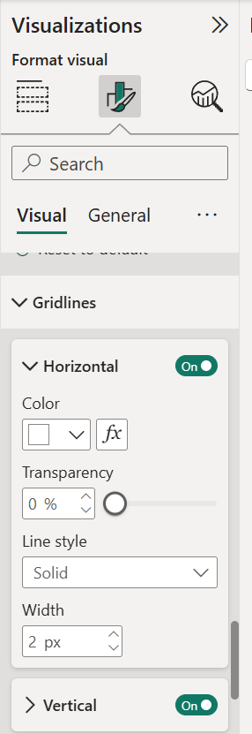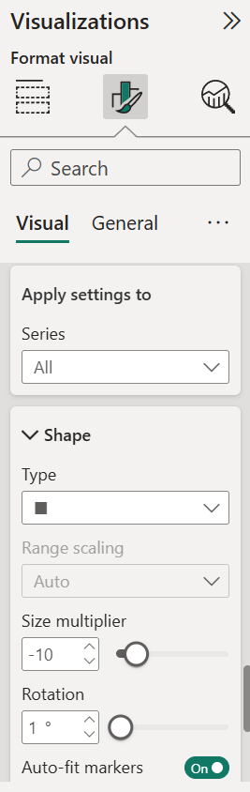

Step 19: Comparison of Total Sales Amount and Target:
Created cards to display the total sales amount alongside the sales target for quick comparison and analysis. Also, created a multi-row card to display the minimum target for each Category.

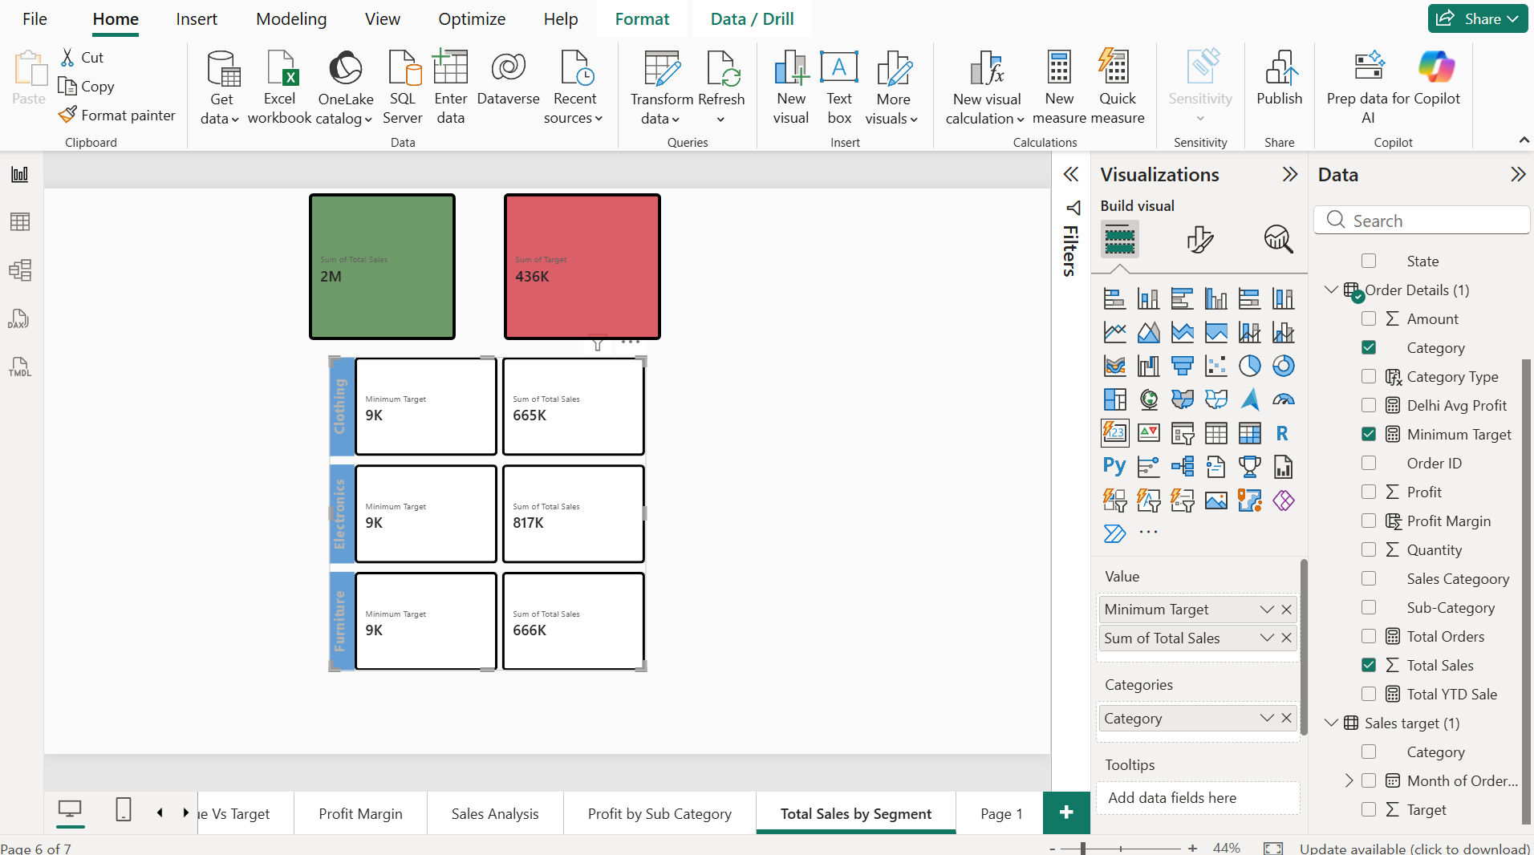

Step 20: Sales Performance Matrix: Built a matrix view to analyse how actual sales compared to
sales targets across different categories and over months.

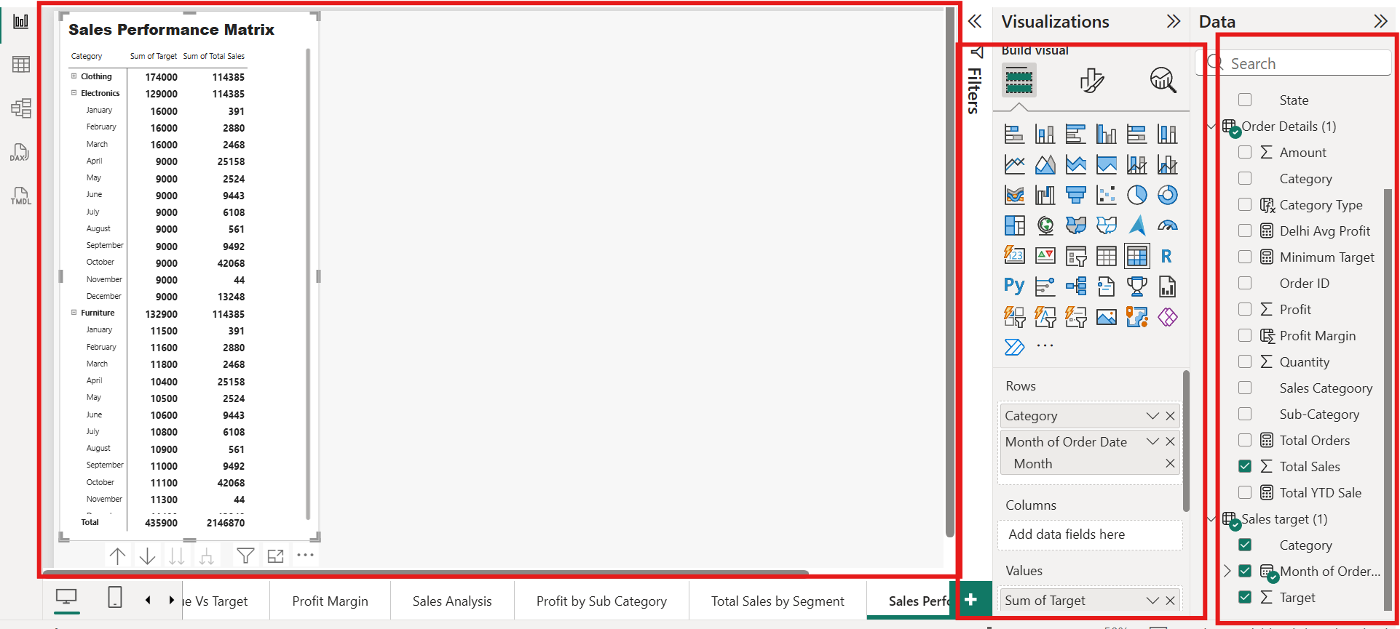

Step 21: Geographical Sales Analysis:
Visualized total sales on a map by city to show regional sales pattern

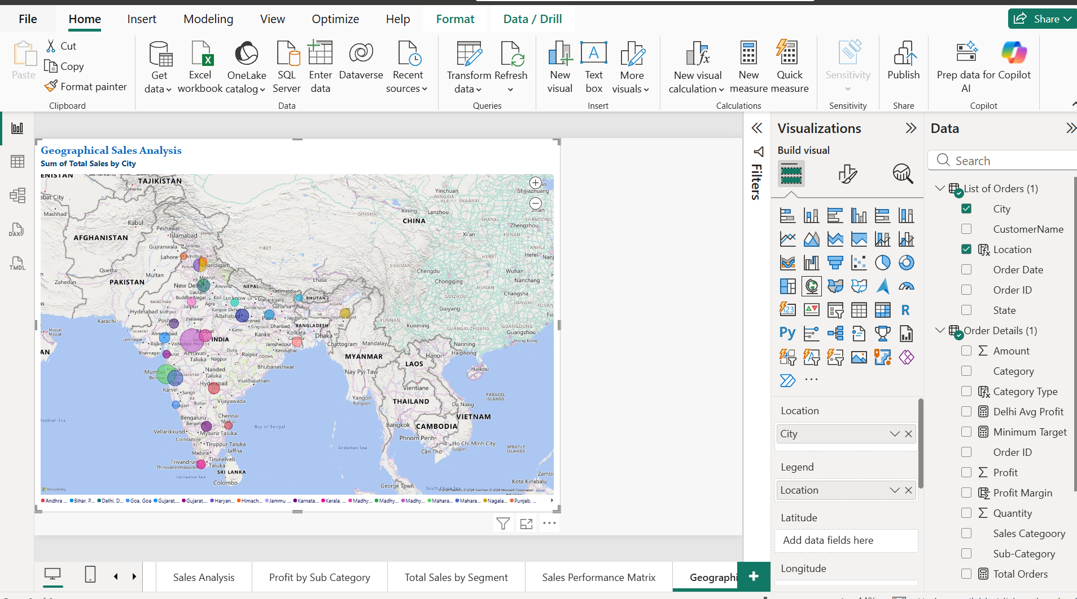

Step 22: Sales Distribution by Sub-Category: Represented the sales distribution across different sub-categories using a Treemap Chart.

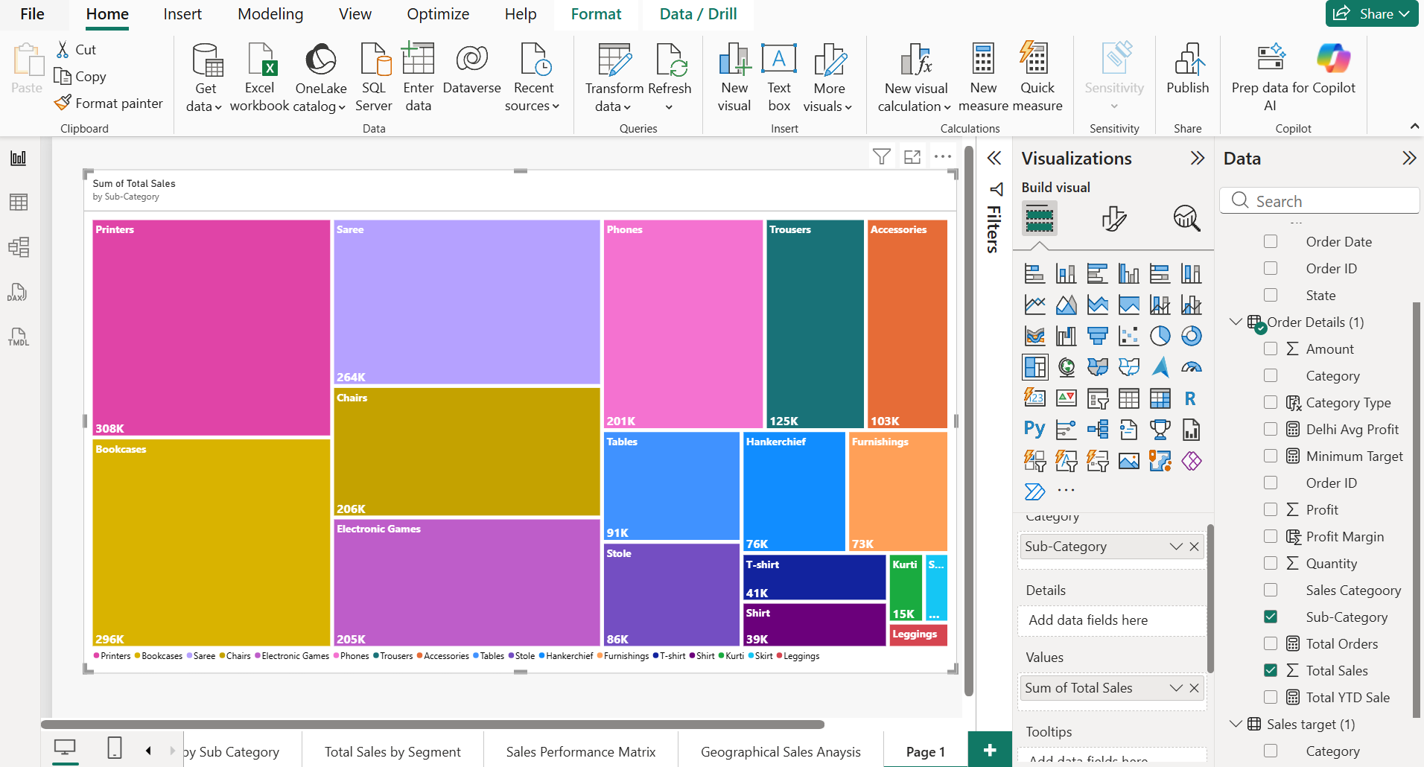
Step 23: Order Count Analysis by State:
Created a funnel chart to visualize the distribution of order counts across different states.
